**LABORATOR 3**

<https://www.w3schools.com/>

<https://developer.mozilla.org/>

<https://www.w3.org/standards/webdesign/>

Ghidul complet de folosire al flexbox-ului il puteti gasi pe [CSS tricks](https://css-tricks.com/snippets/css/a-guide-to-flexbox/). Mai mult, pe [web.dev](https://web.dev/) puteti gasi toate informatiile de baza legate de [responsive web design](https://web.dev/responsive-web-design-basics/). Iar pe link-urile urmatoare: [CSS positioning](https://www.vojtechruzicka.com/css-position) si [CSS Box Model](https://developer.mozilla.org/en-US/docs/Web/CSS/CSS_Box_Model/Introduction_to_the_CSS_box_model), gasiti detalii despre ce am prezentat data trecuta la laborator, in exemplul *divs.html*: <https://github.com/MihaelaIancu/Laborator_Tehnici_Web/tree/main/lab1%262/divs> .

For fun: [Flexbox froggy](https://flexboxfroggy.com/) .

**EXERCITII**

EX1. Completati codul atasat laboratorului cu stilurile meniului pentru mobil (la rezolutie mai mica de 768px) si tableta (la rezolutie mai mica de 990px) folosind [CSS media queries](https://web.dev/responsive-web-design-basics/#media-queries) astfel incat sa arate ca in imaginea de mai jos.



EX2. Avem urmatoarele imagini in *portfolio.html*.

* <https://picsum.photos/seed/a/400/400>
* <https://picsum.photos/seed/b/400/400>
* <https://picsum.photos/seed/c/400/400>
* <https://picsum.photos/seed/d/400/400>
* <https://picsum.photos/seed/e/400/400>
* <https://picsum.photos/seed/f/400/400>

Stilizati imaginile cu ajutorul [Flexbox-ului](https://css-tricks.com/snippets/css/a-guide-to-flexbox/) astfel incat sa respecte aspectul designul de mai jos. Numarul de coloane folosit pentru afisarea imaginilor trebuie sa difere in functie de rezolutie (folositi [CSS media queries](https://web.dev/responsive-web-design-basics/#media-queries)):

* rezolutie mai mica de 768px - 1 coloana (telefon mobil)
* rezolutie mai mica de 990px - 2 coloane (tableta)
* rezolutie mai mare de 990px - 3 coloane (desktop)

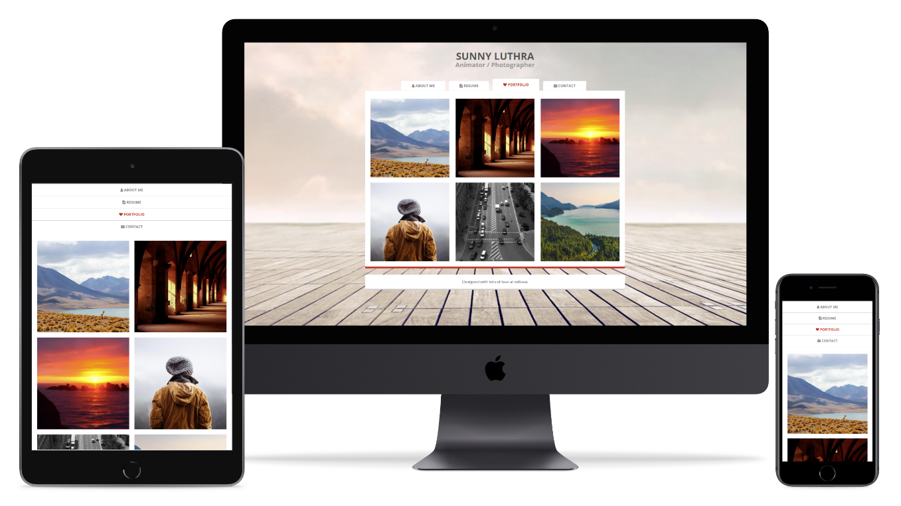

EX3. Creati un document HTML (*contact.html*) si includeti libraria [Font Awesome](https://fontawesome.com/v4.7.0/get-started/) folosind-o pentru a afisa o iconita in pagina.

